Проект урока

Учителя английского языка

МКОУ «Ванашинская ООШ»

Арсланова Асият Закарьяевна

***Цель – «Формирование коммуникативной компетенции учащихся через комплексное обучение всем видам речевой деятельности»***

**Тема урока: «St. Valentine’s Day»**

**Предмет: английский язык**

**Класс: 6**

**Тип урока: комбинированный урок**

2024г.

**План урока.**

**Цель *– формирование коммуникативной компетенции учащихся через комплексное обучение всем видам речевой деятельности.***

**Задачи урока:**

1. **Практические:**

- усвоить новые лексические единицы по теме «St. Valentine’s day»;

- развить навыки ознакомительного чтения;

- научиться извлекать конкретную информацию из аудитивного текста;

- составлять монологическое и диалогическое высказывание на основе прочитанного;

1. **Общеобразовательные:**

- способствовать расширению филологического кругозора учащихся;

- способствовать увеличению словарного запаса.

1. **Развивающие:**

- способствовать развитию памяти, внимания, умения работать в парах, группах, индивидуально;

- способствовать развитию умения оценивать и анализировать свою и коллективную деятельность.

1. **Воспитательные:**

- способствовать воспитанию чувства уважения и толерантности к культуре и истории другого языка;

- содействовать развитию чувства ответственности и взаимовыручки в условиях коллективной работы.

**Оснащение урока:**

1. Проектор мультимедиа, экран.
2. Презентация Power Point “Happy St. Valentine’s day”
3. Карточки для семантизации НЛЕ.
4. Лексические карточки «Broken hearts».
5. Бланки для текста на аудирование.
6. Карточки для домашнего задания.

ХОД УРОКА

1. **Подготовка учащихся к иноязычной деятельности.**
2. *Организационная часть.*

- Good morning, boys and girls! How are you? I’m very glad that everything is ok. You may sit down.

1. *Сообщение темы, цели урока.*

Today we are going to speak about the holiday of love. Can you guess what day I’m talking about? Our lesson is devoted to St. Valentine’s Day, which is always held on the 14th of February and brings us happiness and good luck.

1. **Ознакомление учащихся с новыми лексическими единицами.**
2. *Семантизация НЛЕ.*

Let’s learn some words on this topic. I give you cards with the new words. Let’s learn them together. *Отработка в хоровом режиме*

* Let’s begin with the nouns.
* Now, let’s find only adjectives.
* And what about the last three expressions. What are them?

|  |  |
| --- | --- |
| 1. *Saint Valentine’s day – День Святого Валентина* 2. *a heart – сердце* 3. *Happy Valentine’s day – С днём Святого Валентина* 4. *a valentine – валентинка* 5. *a box of chocolate – коробка шоколада* 6. *candy hearts – сладкие сердца* 7. *Cupid – Купидон* 8. *an arrow – стрела* 9. *a date – свидание* | 1. *writing a valentine – написание валентинки* 2. *sending a valentine – послание валентинки* 3. *getting a valentine – получение валентинки* 4. *popular – популярный* 5. *cross – сердитый* 6. *embarrassed – смущенный* 7. *carnations – гвоздики* 8. *love struck – влюбленный* 9. *a rose – роза* |

1. *Первичная автоматизация НЛЕ. (слайд)*

* Look at the presentation. Choose the most suitable picture for the word.
* Make some words combinations with these words.
* What do you like most to get, to send or to write valentines?

1. *Закрепление новой лексики (слайд)*

* Now, I give you special cards. This is a **Valentine’ day riddle.**

Mend these broken hearts to figure out the hidden message.

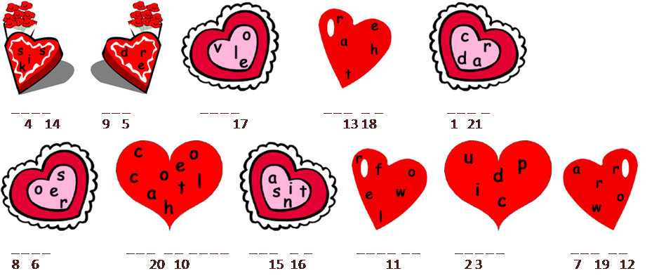

Use the numbers above to fill the riddle and answer my question: Why did the dog and cat fall in love?

* P1, Please go to the blackboard and write down these letters.

1. **Развитие видов речевой деятельности.**
2. *Развитие навыков монологической речи по образцу.*

- Children, do you know anything about the history of the holiday? I asked you to prepare some information at home and you worked at groups. The first group will tell us about the history of the holiday. The second will tell us about the symbols of St. Valentine’s Day. Tell us what you have found. But be attentive and answer my questions.

1. When did the holiday of St. Valentine’s Day appear?

2. Whom was Valentine?

3. “Love from your Valentine”. How did this phrase become symbolic?

There is a beautiful legend about St. Valentine’s Day. Saint Valentine lived in Rome in the third century AD. At the time the Emperor or Rome was Claudius. He wasn’t very popular because he was trying to get more and more people for his army. The men didn’t want to go to the army and Claudius thought that it was because they didn’t want to leave their wives and children. “If they don’t get married, they will join the army,” he thought and passed a law which banned marriage.

Valentine was a Christian priest who didn’t like the new law. He secretly married people who were in love. One night the Emperor’s soldiers caught him and put him in prison. Valentine was going to die.

Many young people felt sorry for Valentine and visited him in prison. One of them was the daughter of a prison guard. On the day of his execution Valentine wrote a note to her and singed it “Love from your Valentine”. This was on 14 February 269 AD.

Since then the 14th of February has been the Day of Love, when people send love letters and presents to each other. They don’t sign the cards with their names, but write “Guess Who” or “Your Valentine”.

At first this was a European tradition, but then it became popular in other countries. It came to Russia too, but a lot of people say, “If you love somebody, you should show it every day, not only one day a year”.

Nowadays the symbol of St. Valentine’s Day is Cupid a son of Venus, goddess of love. He could cause people to fall in love by piercing them with one of his magic arrows.

The rose was the flower of Venus, the Roman god of love. Red is a colour that stands for strong feelings. That is why the red rose is a flower of love.

A long time ago, people believed that all the emotions were found in the heart. In later years, they thought only the emotion of love was connected with the heart. The heart is still a symbol of love, and it is also a symbol of Valentine’s Day.

1. *Обучение аудированию.*

ОЗУ: Listen to the text.

**Text**

BE MY VALENTINE!

February 14th is Valentine’s day. Valentine’s Day is a day for romance and love. It also a day for a fun!

You see a lot of romantic symbols you may see include roses (because roses are thought to be a romantic flower), Cupid (a little boy who can make people fall in love with his special bow and arrow), and hearts.

Hearts are probably the most common Valentine’s Day symbol. People make pictures in the shape of a heart. People buy candles and balloons and many other things in the shape of a heart. You can even find candy in the shape of a heart!

On Valentine’s Day, people give cards and presents to each other. The cards are called valentines. Some people buy the cards. Other people make the cards. The presents might be something small and sweet or something big and dramatic. Some people get engaged (promise to marry each other) on Valentine’s Day.

Some schools have valentine parties. The students give each other valentines. They eat heart-shaped candy.

**Проверка понимания прослушанного текста.**

ОЗУ: Аnswer the questions about St. Valentine Day

1. Valentine’s Day is in the month of .
   1. April
   2. May
   3. February
   4. December
2. Valentine’s Day is a day.
   1. lovely and lonely
   2. romantic and playful
   3. patriotic
   4. none of the above
3. What are some things that are heart-shaped?
   1. candy
   2. cards
   3. pictures
   4. all of these
4. What are some symbols of Valentine’s Day?
   1. Cupid, roses and hearts
   2. eggs, bacon and roses
   3. candy, roses and livers
   4. none of the above
5. What do many people do on Valentine’s Day?
   1. They give presents and cards.
   2. They have heart problems.
   3. They eat candy canes.
   4. They look for eggs.
      1. c
      2. b
      3. d
      4. a
      5. a
6. *Обучение письменной речи.*

ОЗУ: and the last task for today: please, make valentine cards to our guests from Shakhunya. You have only 3 minutes for that. Examples will help you.

1. **Заключительный этап.**
   * + 1. *Проверка и оценка результатов. Рефлексия*

That brings us to the end. You worked well during the lesson.

Estimate yourself now. How did you work today.

Ребята, давайте подведем итоги урока, каких целей мы добились сегодня, а над чем нам нужно поработать еще?

Начните фразу так, это был полезный урок потому что….

* + - 1. *Домашнее задание.*

Write down your homework: Find the Valentine’s Day words below the grid:



Mind the clock

And keep the rule:

Try to come in time to school.

Our lesson is over. Good-bye, boys and girls!

BrokentHearts

|  |  |  |  |  |  |  |  |  |  |  |  |  |  |  |  |  |  |  |
| --- | --- | --- | --- | --- | --- | --- | --- | --- | --- | --- | --- | --- | --- | --- | --- | --- | --- | --- |
| Valentine’s Day Riddle: Use the numbers above to fill in the riddle.  Why did the dog and cat fall in love? | | | | | | | | | | | | | | | | | | |
|  | **__** | **__** | **__** | **__** | **__** | **’** | **__** |  | **__** | **__** | **__** | **__** | **__** |  | **__** | **__** | **__** |  |
|  | 1 | 2 | 3 | 4 | 5 |  | 6 |  | 7 | 8 | 9 | 10 | 11 |  | 12 | 13 | 14 |  |
|  |  |  |  |  | **__** | **__** |  | **__** | **__** | **__** | **__** | **__** |  |  |  |  |  |  |
|  |  |  |  |  | 15 | 16 |  | 17 | 18 | 19 | 20 | 21 |  |  |  |  |  |  |



